**CURRICULUM VITAE**

Name : Md. Shahidur Rahaman 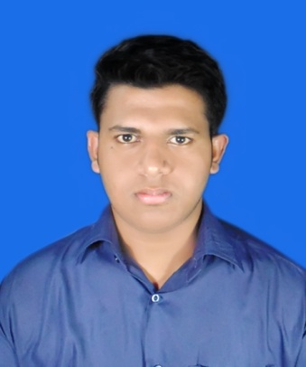   
Phone No : 01521103117  
Email : Sr.himel5@gmail.com

**Personal Information**  
  
Father Name : Md. Habibur Rahaman  
Mother Name : Amina Begum  
Date of Birth : 15-04-1996  
Nationality : Bangladeshi  
Religion : Islam   
Permanent Address: High School Road, Dhaligour Nagar, Lalmohan , Bhola.

Present Address : Halim Road, Baganbari , Dhaka Cantonment, Dhaka-1206.

|  |  |  |  |  |
| --- | --- | --- | --- | --- |
| SSC | Name of Institute | Board | Year | GPA |
| Ispahani Public School and College | Comilla | 2011 | 5.00 |
| HSC | Rajuk Uttara Model College | Dhaka | 2013 | 5.00 |

**Educational Information**University Name: Military Institute of Science and Technology  
 Currently Studying in Level-3

Department : Computer Science and Engineering (CSE)